Test Case: tc003_SPX_Dev5_Validar_Funcionalidad_Botones_Add_Remove_Administrador_Roles_Menu
Step 1 - Enter username and password and click to button Enter : Credentials Entered
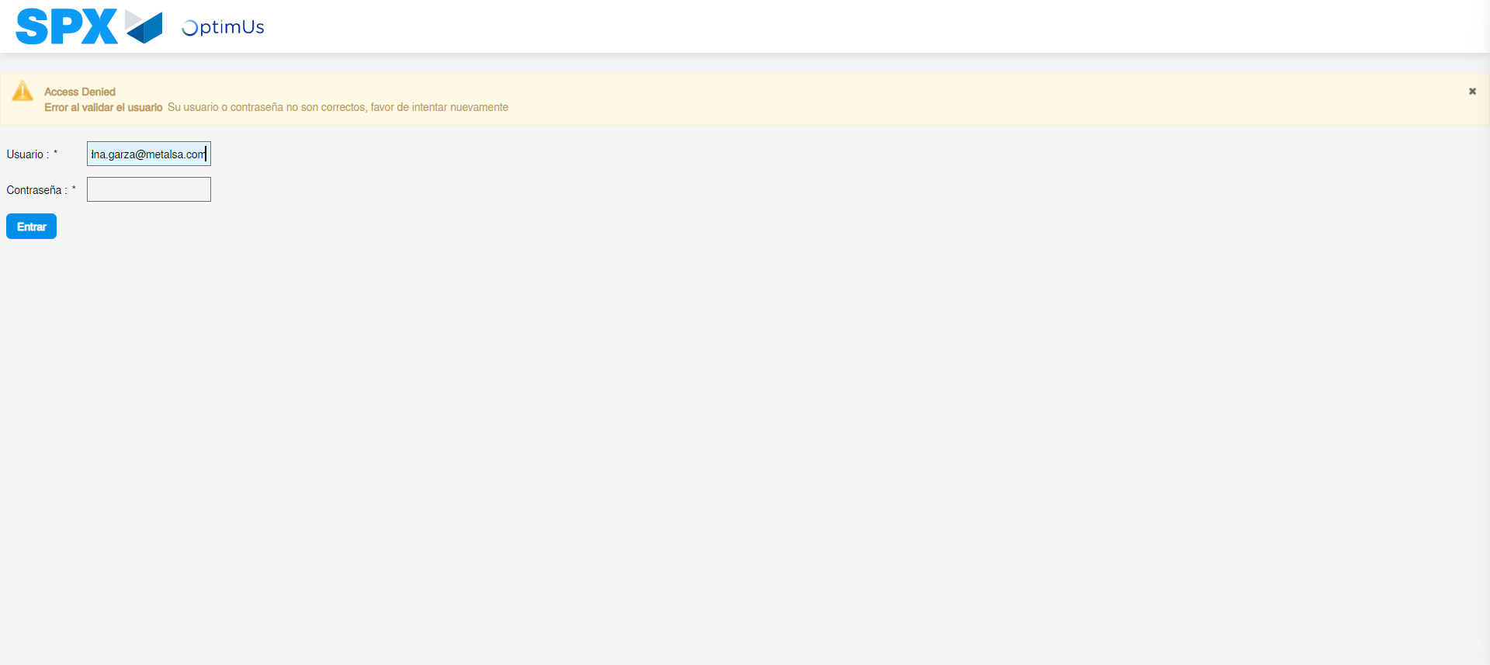Image file-name: QC_Testing-tc003_SPX_Dev5_Validar_Funcionalidad_Botones_Add_Remove_Administrador_Roles_Menu-may. 15 2024, 12 59 48 p. m.

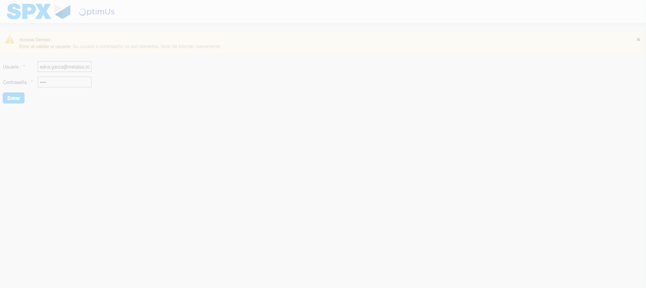Image file-name: QC_Testing-tc003_SPX_Dev5_Validar_Funcionalidad_Botones_Add_Remove_Administrador_Roles_Menu-may. 15 2024, 12 59 49 p. m.

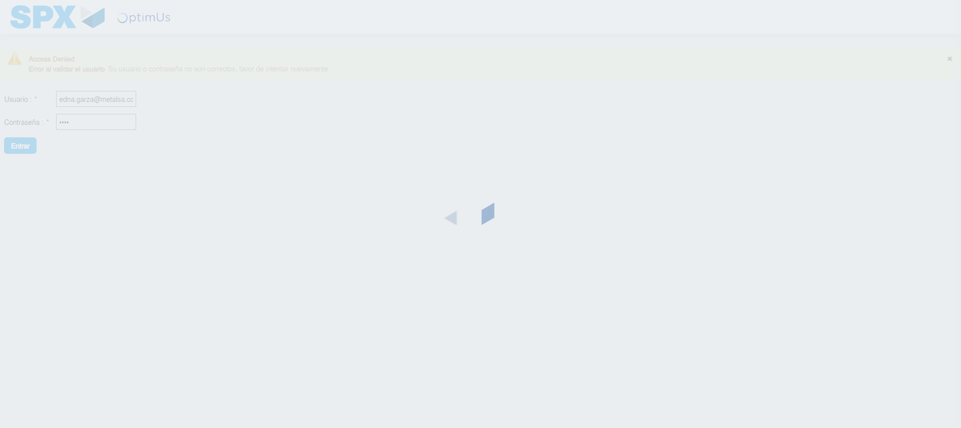Image file-name: QC_Testing-tc003_SPX_Dev5_Validar_Funcionalidad_Botones_Add_Remove_Administrador_Roles_Menu-may. 15 2024, 12 59 50 p. m.

Step 2 - Select to UEN and Access to Administrador Roles Menu: UEN Correctly selected and Correct access
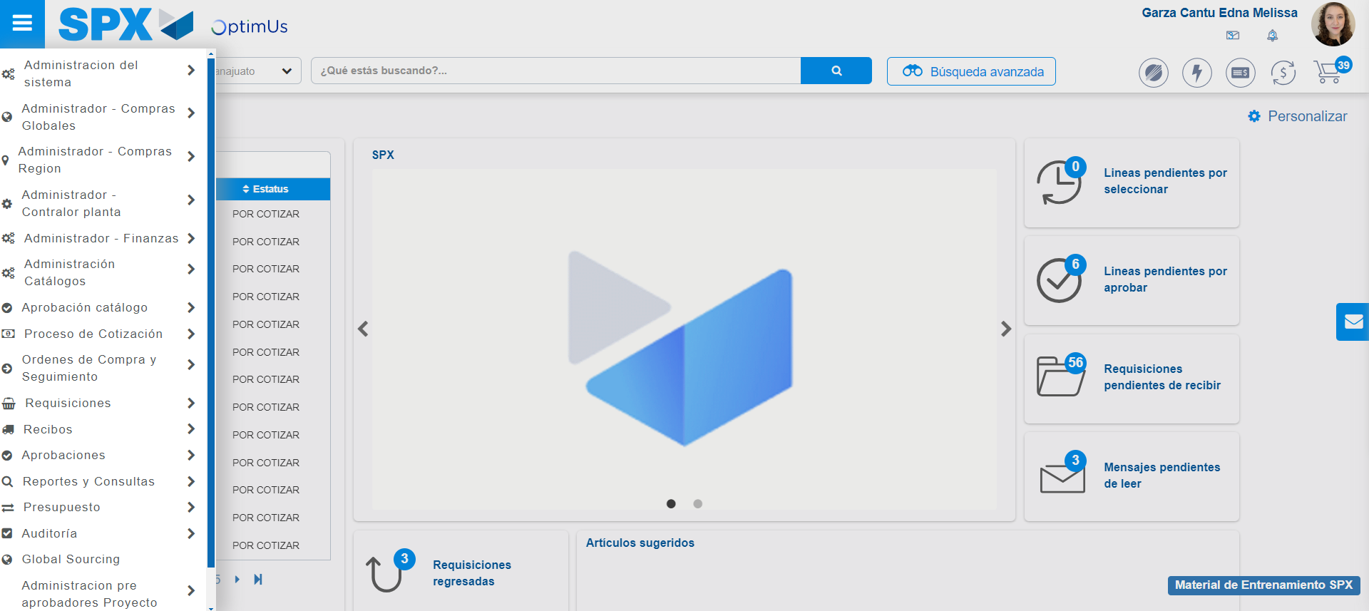Image file-name: QC_Testing-tc003_SPX_Dev5_Validar_Funcionalidad_Botones_Add_Remove_Administrador_Roles_Menu-may. 15 2024, 01 00 00 p. m.

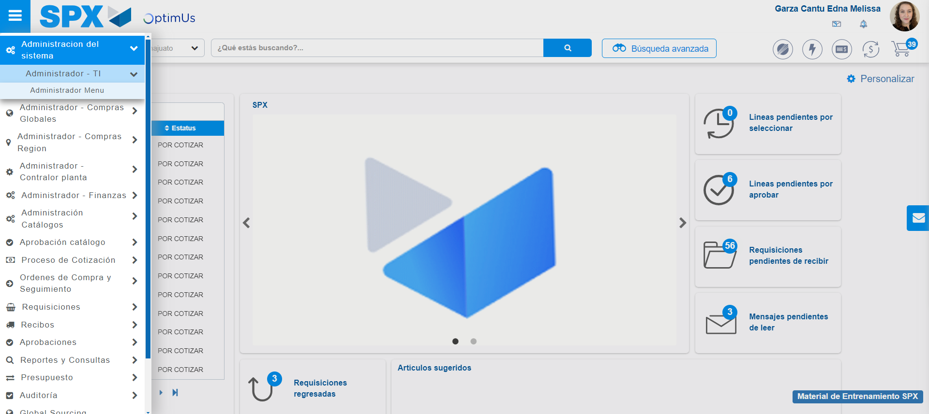Image file-name: QC_Testing-tc003_SPX_Dev5_Validar_Funcionalidad_Botones_Add_Remove_Administrador_Roles_Menu-may. 15 2024, 01 00 01 p. m.

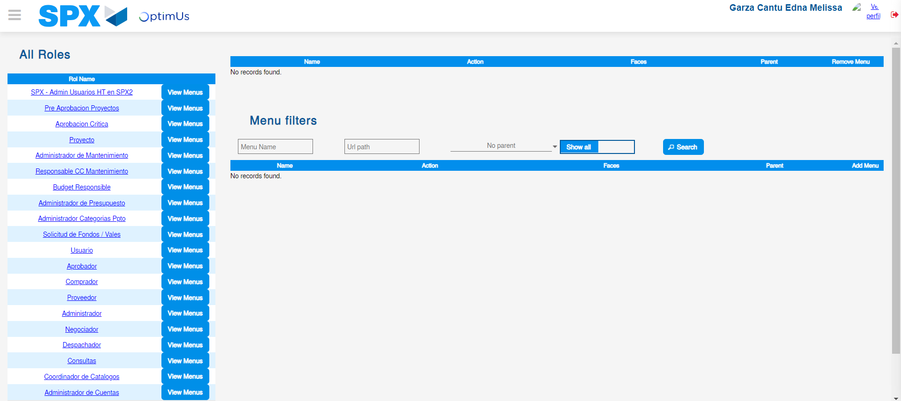Image file-name: QC_Testing-tc003_SPX_Dev5_Validar_Funcionalidad_Botones_Add_Remove_Administrador_Roles_Menu-may. 15 2024, 01 00 05 p. m.

Image file-name: QC_Testing-tc003_SPX_Dev5_Validar_Funcionalidad_Botones_Add_Remove_Administrador_Roles_Menu-may. 15 2024, 01 00 06 p. m.

Image file-name: QC_Testing-tc003_SPX_Dev5_Validar_Funcionalidad_Botones_Add_Remove_Administrador_Roles_Menu-may. 15 2024, 12 59 56 p. m.

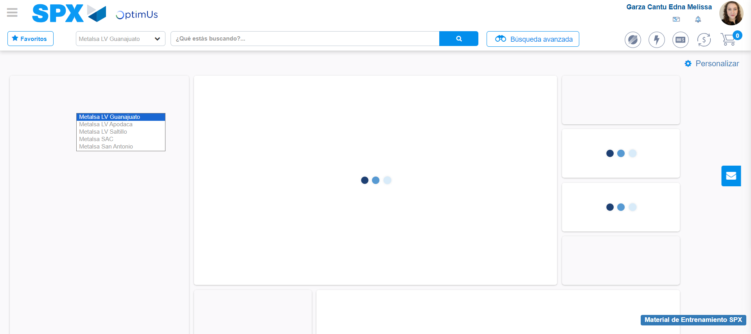Image file-name: QC_Testing-tc003_SPX_Dev5_Validar_Funcionalidad_Botones_Add_Remove_Administrador_Roles_Menu-may. 15 2024, 12 59 57 p. m.

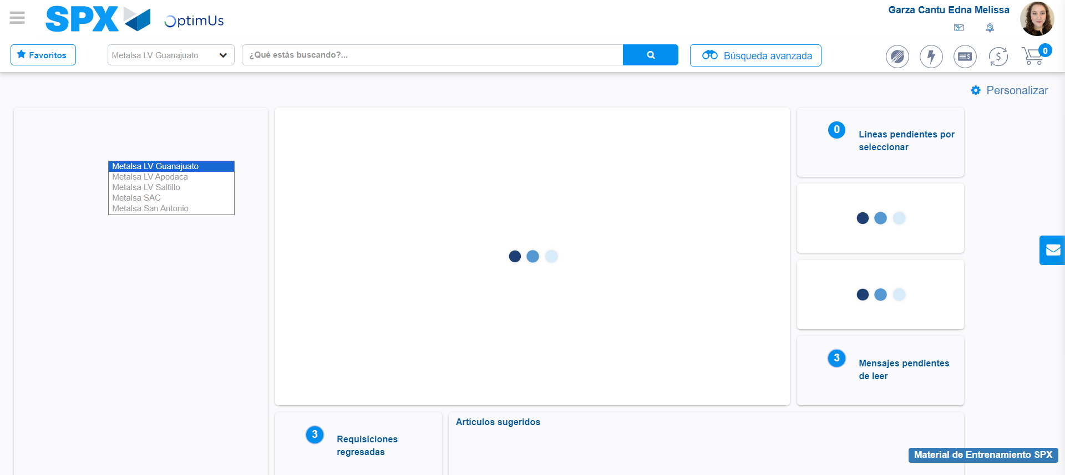Image file-name: QC_Testing-tc003_SPX_Dev5_Validar_Funcionalidad_Botones_Add_Remove_Administrador_Roles_Menu-may. 15 2024, 12 59 58 p. m.

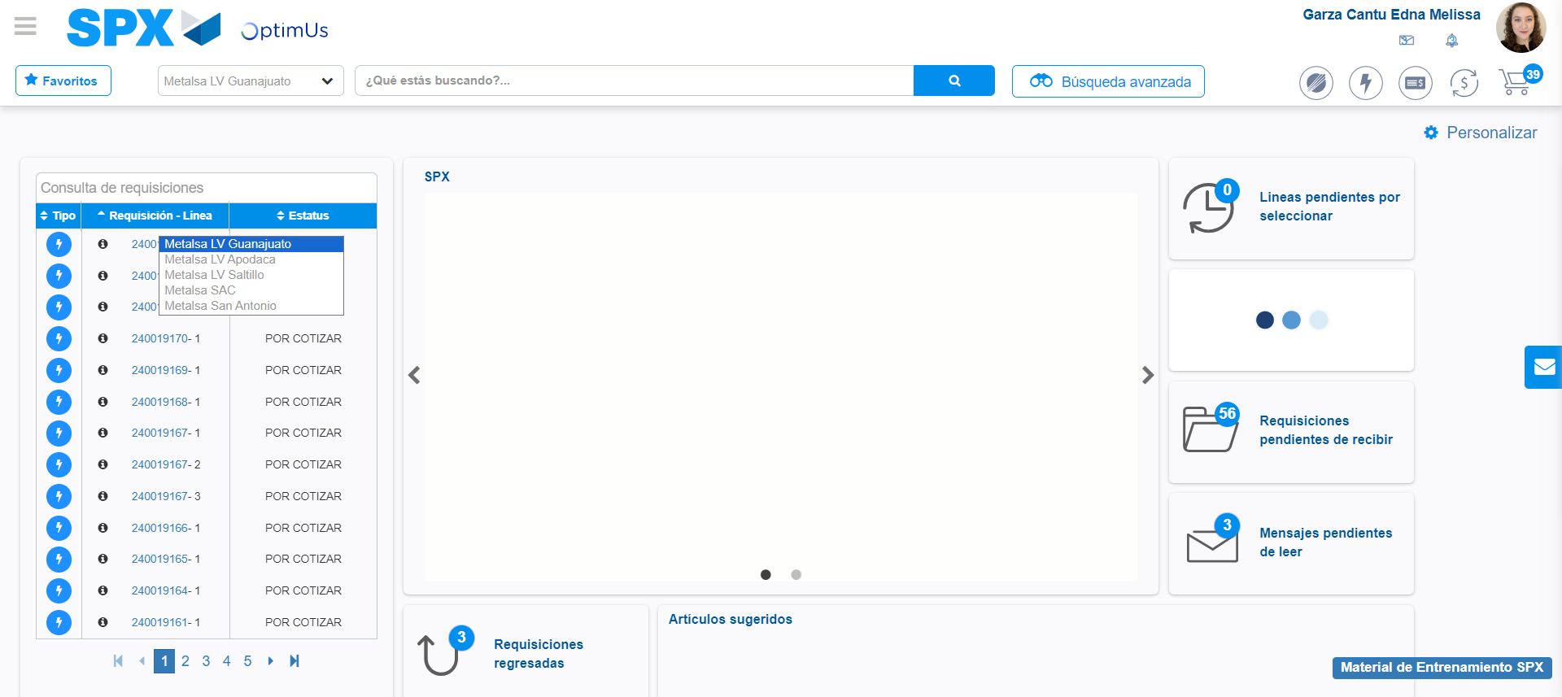Image file-name: QC_Testing-tc003_SPX_Dev5_Validar_Funcionalidad_Botones_Add_Remove_Administrador_Roles_Menu-may. 15 2024, 12 59 59 p. m.

Step 3 - Click to Buttons View Menu and Search Filter with Menu Name and Add new record and Delete Record: Correct Search and Record successfully added and Record successfully deleted
Image file-name: QC_Testing-tc003_SPX_Dev5_Validar_Funcionalidad_Botones_Add_Remove_Administrador_Roles_Menu-may. 15 2024, 01 00 06 p. m.

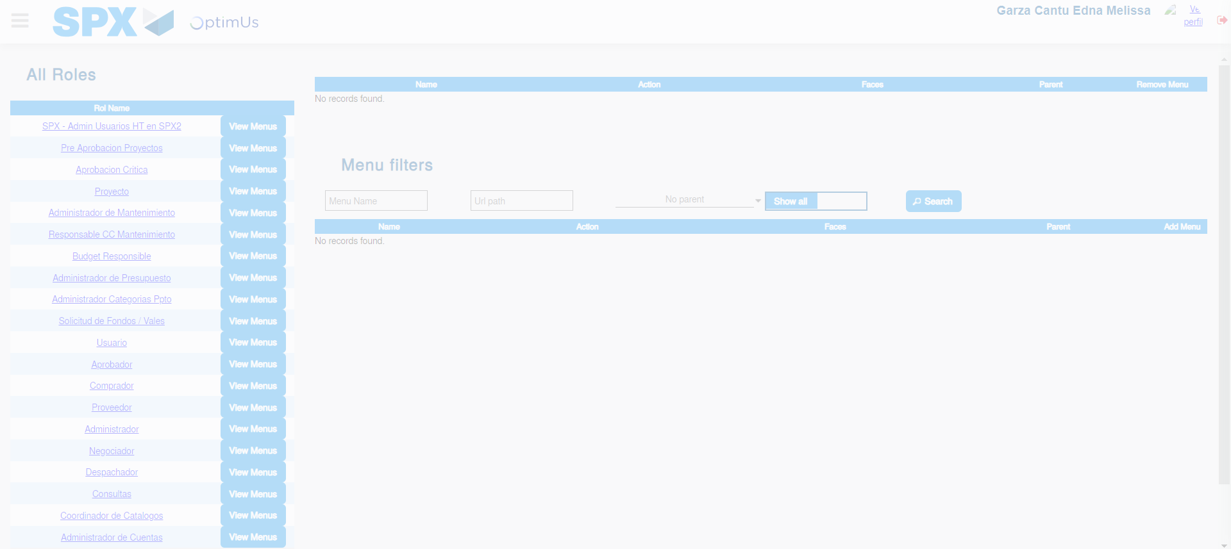Image file-name: QC_Testing-tc003_SPX_Dev5_Validar_Funcionalidad_Botones_Add_Remove_Administrador_Roles_Menu-may. 15 2024, 01 00 07 p. m.

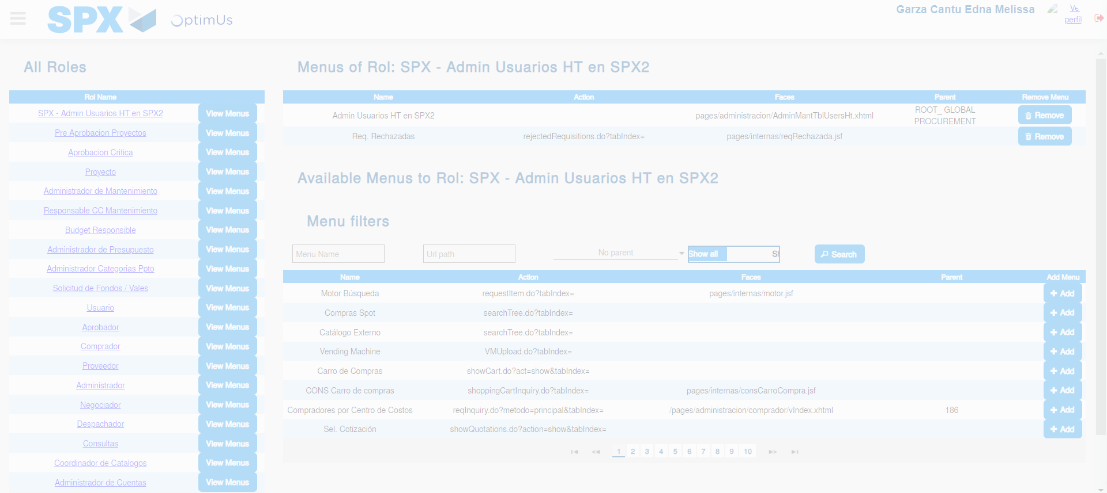Image file-name: QC_Testing-tc003_SPX_Dev5_Validar_Funcionalidad_Botones_Add_Remove_Administrador_Roles_Menu-may. 15 2024, 01 00 08 p. m.

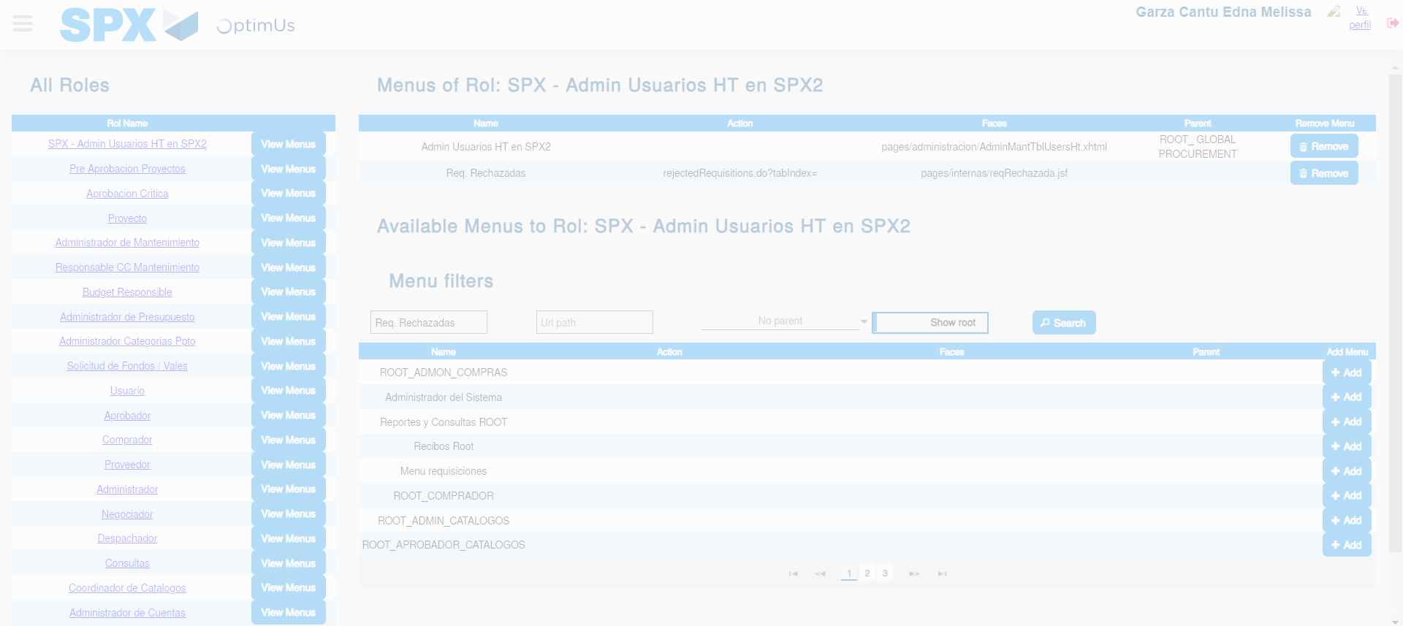Image file-name: QC_Testing-tc003_SPX_Dev5_Validar_Funcionalidad_Botones_Add_Remove_Administrador_Roles_Menu-may. 15 2024, 01 00 09 p. m.

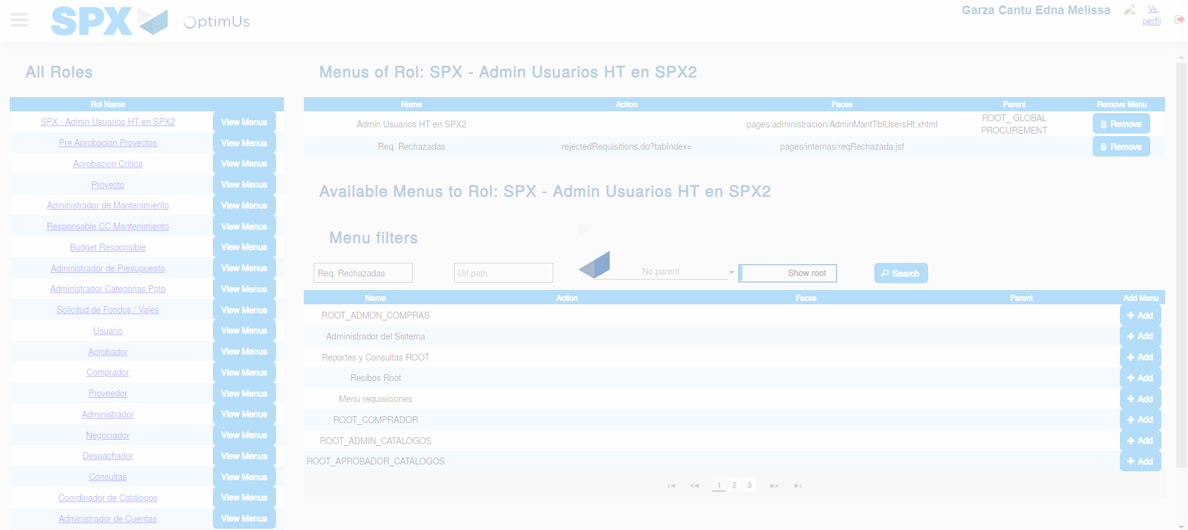Image file-name: QC_Testing-tc003_SPX_Dev5_Validar_Funcionalidad_Botones_Add_Remove_Administrador_Roles_Menu-may. 15 2024, 01 00 10 p. m.

Image file-name: QC_Testing-tc003_SPX_Dev5_Validar_Funcionalidad_Botones_Add_Remove_Administrador_Roles_Menu-may. 15 2024, 01 00 11 p. m.

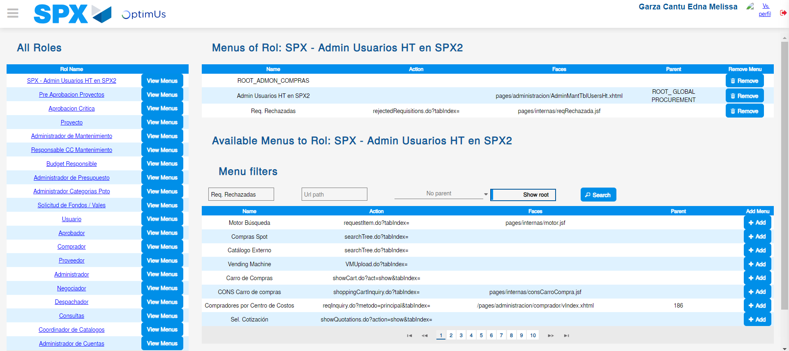Image file-name: QC_Testing-tc003_SPX_Dev5_Validar_Funcionalidad_Botones_Add_Remove_Administrador_Roles_Menu-may. 15 2024, 01 00 15 p. m.

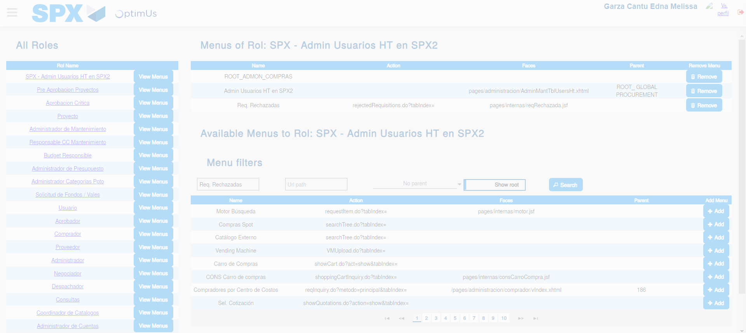Image file-name: QC_Testing-tc003_SPX_Dev5_Validar_Funcionalidad_Botones_Add_Remove_Administrador_Roles_Menu-may. 15 2024, 01 00 16 p. m.

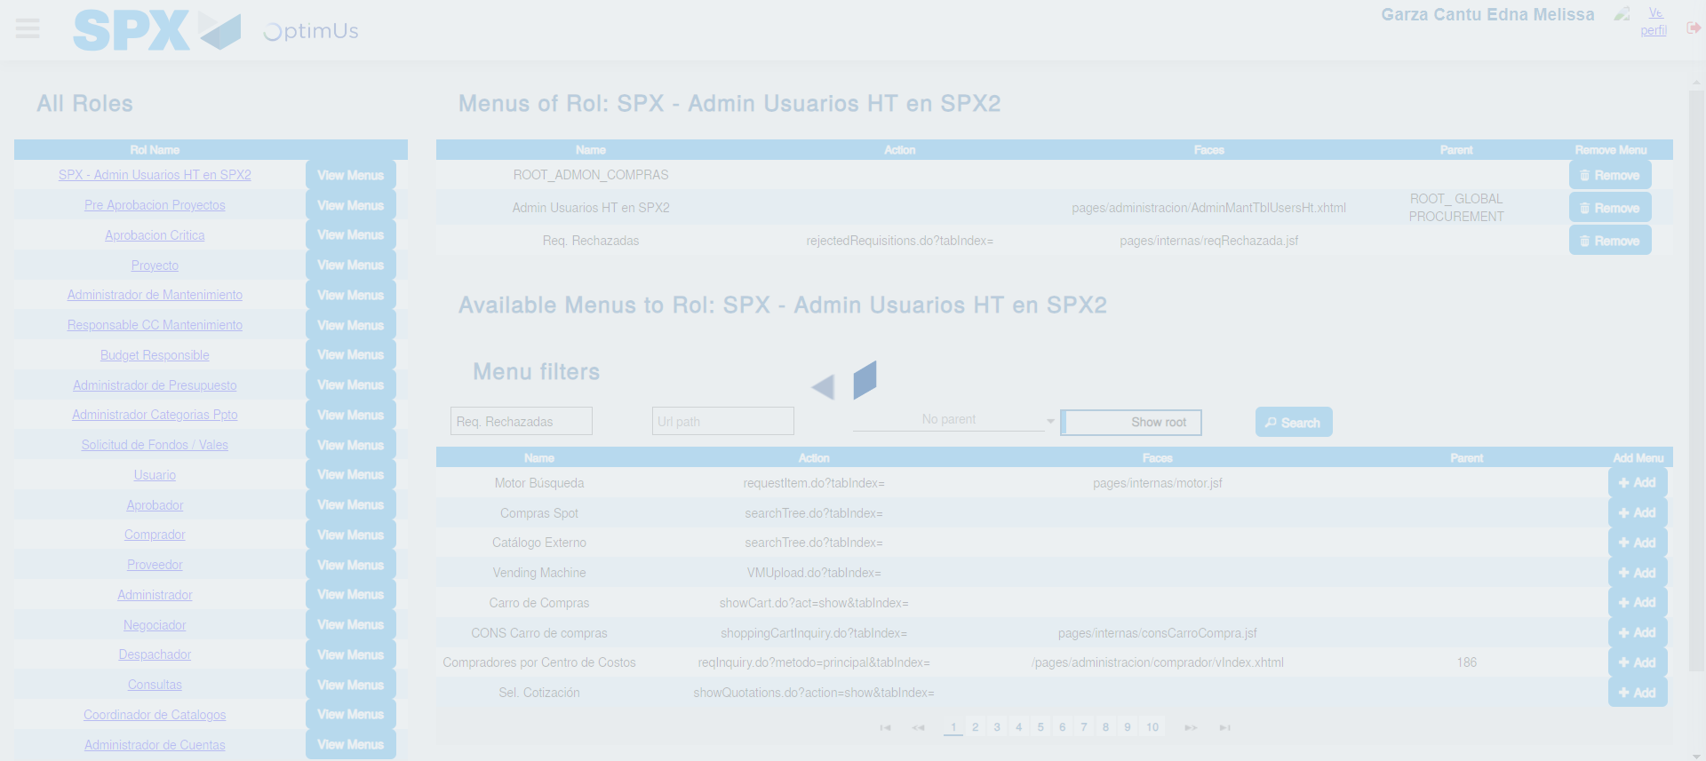Image file-name: QC_Testing-tc003_SPX_Dev5_Validar_Funcionalidad_Botones_Add_Remove_Administrador_Roles_Menu-may. 15 2024, 01 00 17 p. m.

